Great Deltoidal Hexecontahedron

Definition
# Source: AI Source: Provided by: [Data Path: Persons Table -> ID Column: 1, Name_En Column: Motasem Essam] -> From: [ChatGPT] on [7/25/2026]
The Great Deltoidal Hexecontahedron, also known as the Great Strombic Hexecontahedron or Great Sagittal Ditriacontahedron, is a nonconvex isohedral star polyhedron composed of 60 intersecting dart-shaped quadrilateral faces.
It has 120 edges and 62 vertices. It is the dual polyhedron of the Uniform Great Rhombicosidodecahedron.
Unlike the ordinary Deltoidal Hexecontahedron, its faces are nonconvex dart-shaped quadrilaterals, and portions of these faces extend through the solid's interior.
It has full icosahedral symmetry, represented by $I_{h}$.

Geometric Structure
# Source: AI Source: Provided by: [Data Path: Persons Table -> ID Column: 1, Name_En Column: Motasem Essam] -> From: [ChatGPT] on [7/25/2026]
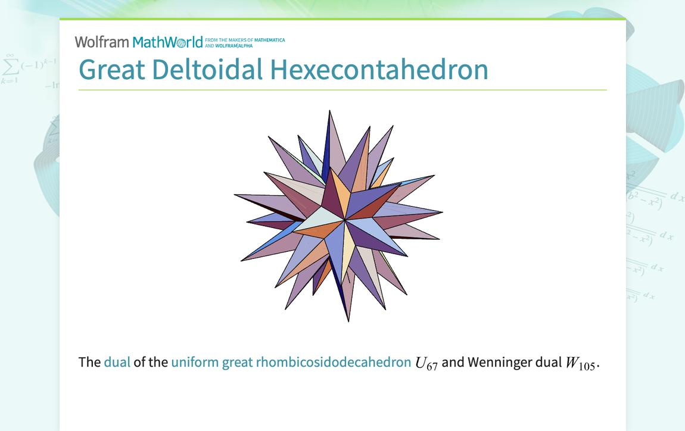
The solid consists of:
- 60 Dart-Shaped Faces: Nonconvex quadrilateral faces, each resembling a dart or arrowhead.
- 120 Edges: Divided into 60 shorter edges and 60 longer edges.
- 62 Vertices: Divided into three groups according to the number of edges meeting at each vertex.
The faces intersect one another, and parts of each dart extend into the interior of the solid.

Face Composition
# Source: AI Source: Provided by: [Data Path: Persons Table -> ID Column: 1, Name_En Column: Motasem Essam] -> From: [ChatGPT] on [7/25/2026]

Face Type | Number | Shape
Dart-Shaped Faces | 60 | Nonconvex quadrilateral
Total Faces | 60 | —
Each dart-shaped face has:
- Two shorter edges of equal length.
- Two longer edges of equal length.
- Two acute angles.
- One obtuse angle.
- One reflex angle greater than ${180}^{°}$.
The faces are congruent and arranged symmetrically throughout the polyhedron.

Mathematical Properties
# Source: AI Source: Provided by: [Data Path: Persons Table -> ID Column: 1, Name_En Column: Motasem Essam] -> From: [ChatGPT] on [7/25/2026]
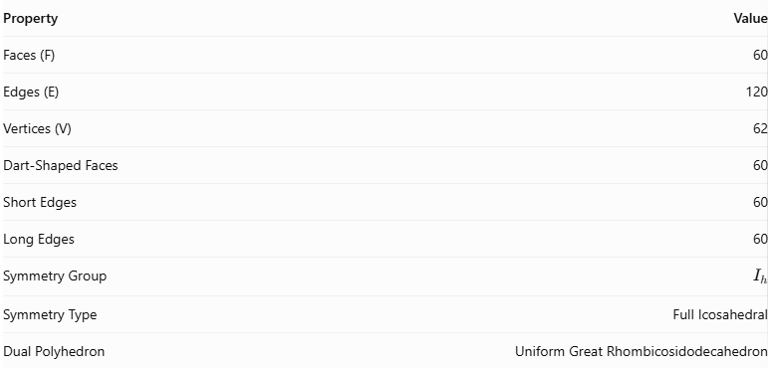
Property | Value
Faces (F) | 60
Edges (E) | 120
Vertices (V) | 62
Dart-Shaped Faces | 60
Short Edges | 60
Long Edges | 60
Symmetry Group | $$I_{h}$$
Symmetry Type | Full Icosahedral
Dual Polyhedron | Uniform Great Rhombicosidodecahedron

Euler's Formula
# Source: AI Source: Provided by: [Data Path: Persons Table -> ID Column: 1, Name_En Column: Motasem Essam] -> From: [ChatGPT] on [7/25/2026]
For a polyhedron:
$$V-E+F=2$$
Substituting the values:
$$62-120+60=2$$
Therefore, Euler's formula is satisfied.

Vertex Classification
# Source: AI Source: Provided by: [Data Path: Persons Table -> ID Column: 1, Name_En Column: Motasem Essam] -> From: [ChatGPT] on [7/25/2026]
The vertices are divided into three groups:
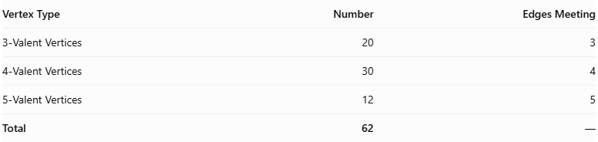
Vertex Type | Number | Edges Meeting
3-Valent Vertices | 20 | 3
4-Valent Vertices | 30 | 4
5-Valent Vertices | 12 | 5
Total | 62 | —

Edge-Length Ratio
# Source: AI Source: Provided by: [Data Path: Persons Table -> ID Column: 1, Name_En Column: Motasem Essam] -> From: [ChatGPT] on [7/25/2026]
The ratio of the longer edge to the shorter edge is:
$$\frac{L}{S}=\frac{21+3\sqrt{5}}{22}$$
Approximately:
$$\frac{L}{S}≈1.25946$$
This means that the longer edge is approximately 1.25946 times the shorter edge.

Dihedral Angle
# Source: AI Source: Provided by: [Data Path: Persons Table -> ID Column: 1, Name_En Column: Motasem Essam] -> From: [ChatGPT] on [7/25/2026]
The dihedral angle is:
$$θ=\cos^{-1}\left(\frac{-19+8\sqrt{5}}{41}\right)$$
Approximately:
$$θ≈{91.5534}^{°}$$
These properties describe the standard dual constructed from the Uniform Great Rhombicosidodecahedron with unit edge length.

Geometric Characteristics
# Source: AI Source: Provided by: [Data Path: Persons Table -> ID Column: 1, Name_En Column: Motasem Essam] -> From: [ChatGPT] on [7/25/2026]
- It is a nonconvex star polyhedron.
- It is an isohedral polyhedron, meaning all faces are equivalent under its symmetry operations.
- It contains 60 congruent dart-shaped faces.
- Its faces are nonconvex quadrilaterals with reflex angles.
- Its edges have two different lengths.
- It has 62 vertices with valencies 3, 4, and 5.
- It has full icosahedral symmetry, represented by $I_{h}$.
- Its dual is the Uniform Great Rhombicosidodecahedron.
- It is visually identical to the Great Rhombidodecacron, a related star polyhedral form.

Geometric Construction
# Source: AI Source: Provided by: [Data Path: Persons Table -> ID Column: 1, Name_En Column: Motasem Essam] -> From: [ChatGPT] on [7/25/2026]
The Great Deltoidal Hexecontahedron is constructed as the dual of the Uniform Great Rhombicosidodecahedron.
The construction follows these steps:
- Begin with the Uniform Great Rhombicosidodecahedron.
- Locate the center of each of its 62 faces.
- Use these face centers as the vertices of the dual polyhedron.
- Connect the centers of adjacent faces according to the original polyhedron's topology.
- Construct one dart-shaped face for each vertex of the original solid.
- Complete the dual structure to obtain 60 intersecting dart-shaped faces.
- Preserve the correct edge lengths and symmetry throughout the construction.
The original solid's 62 faces become the 62 vertices of the dual, while its 60 vertices become the 60 faces of the Great Deltoidal Hexecontahedron.

Related Geometric Solids

Uniform Great Rhombicosidodecahedron
# Source: AI Source: Provided by: [Data Path: Persons Table -> ID Column: 1, Name_En Column: Motasem Essam] -> From: [ChatGPT] on [7/25/2026]
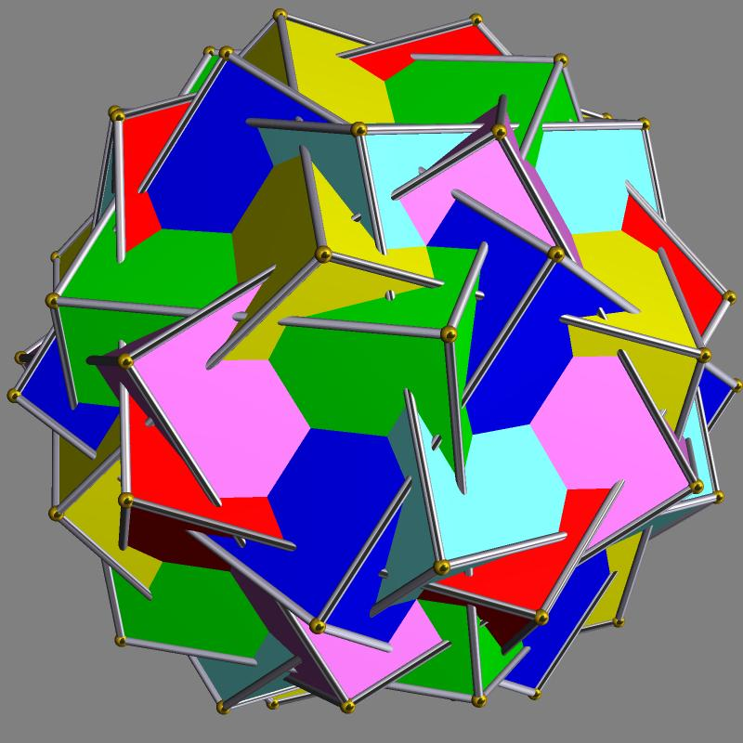
The nonconvex uniform polyhedron whose dual is the Great Deltoidal Hexecontahedron.

Deltoidal Hexecontahedron
# Source: AI Source: Provided by: [Data Path: Persons Table -> ID Column: 1, Name_En Column: Motasem Essam] -> From: [ChatGPT] on [7/25/2026]
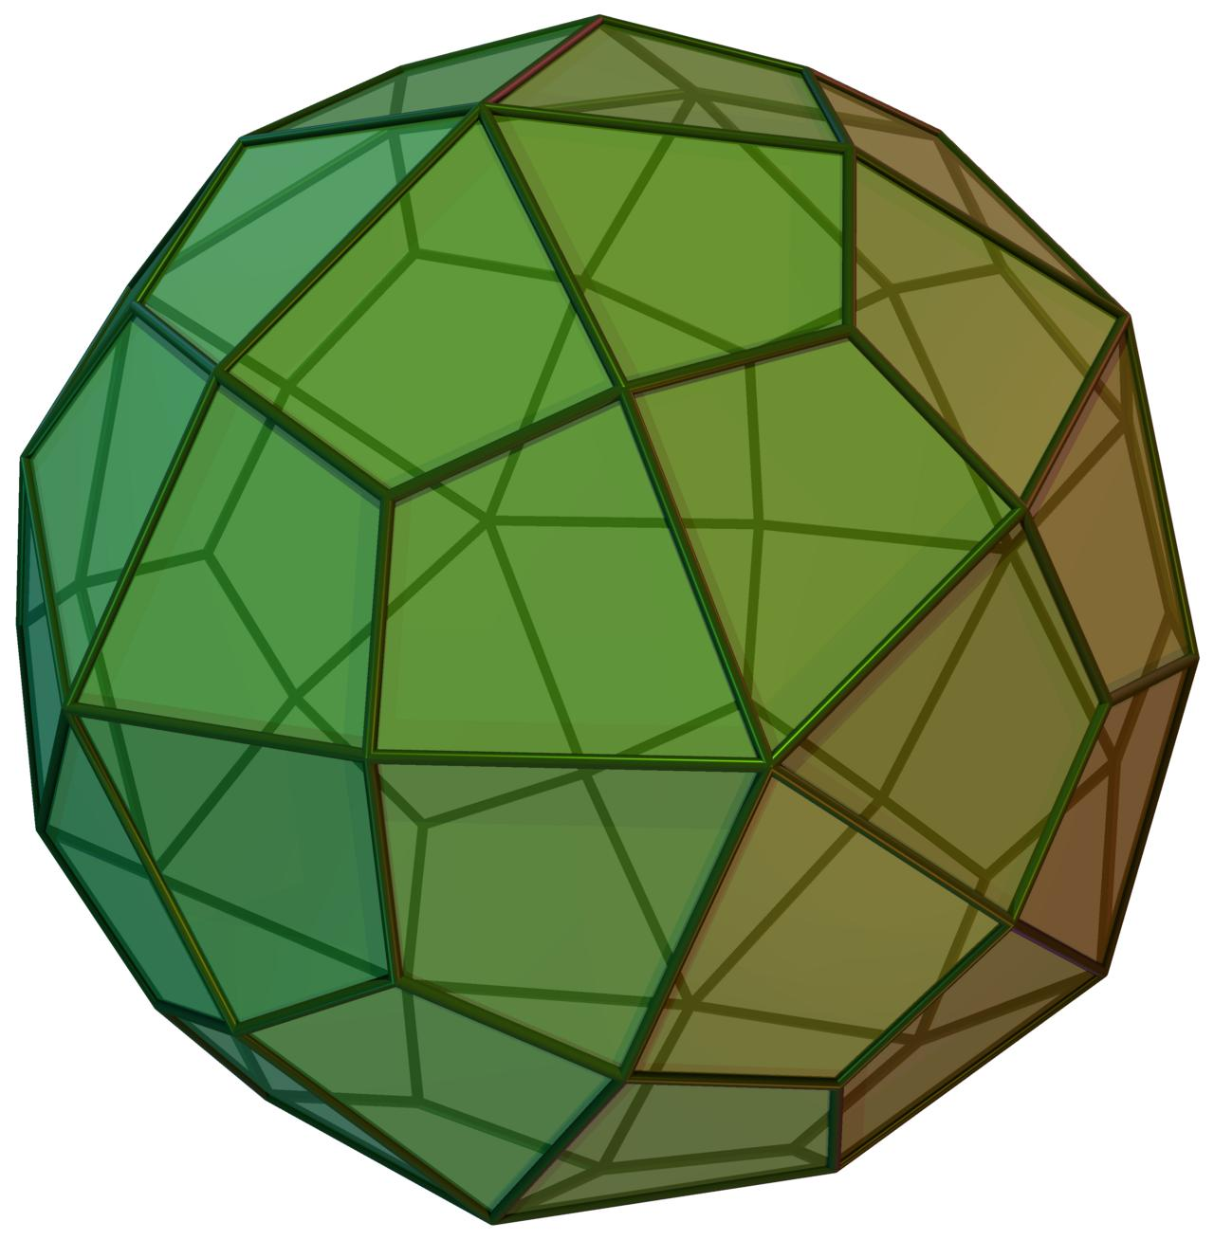
A different, convex Catalan solid composed of 60 congruent kite-shaped faces.

Great Rhombidodecacron
# Source: AI Source: Provided by: [Data Path: Persons Table -> ID Column: 1, Name_En Column: Motasem Essam] -> From: [ChatGPT] on [7/25/2026]
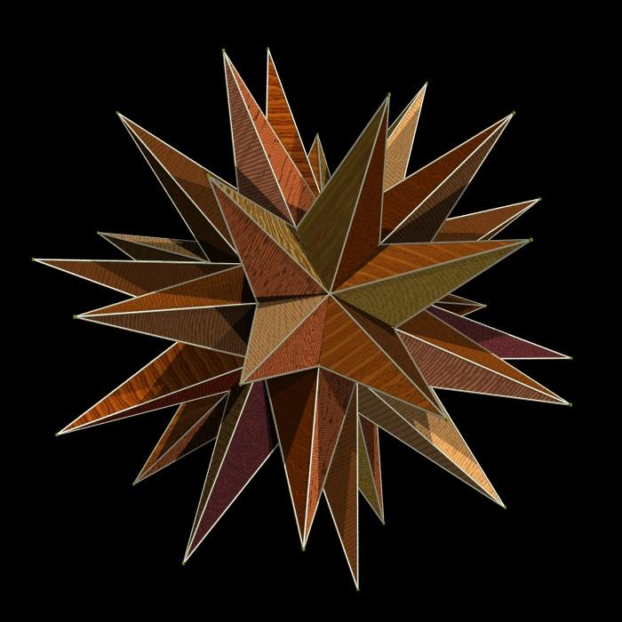
A visually identical star polyhedral form associated with the Great Deltoidal Hexecontahedron.

Great Disdyakis Triacontahedron
# Source: AI Source: Provided by: [Data Path: Persons Table -> ID Column: 1, Name_En Column: Motasem Essam] -> From: [ChatGPT] on [7/25/2026]
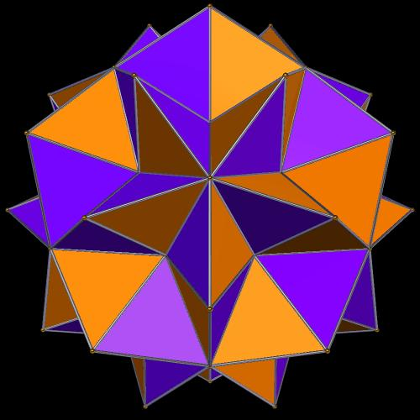
Another complex star-related polyhedron with a different face structure and dual relationship.

Construction of Great Deltoidal Hexecontahedron

Geometric Instruments Used
# Source: AI Source: Provided by: [Data Path: Persons Table -> ID Column: 1, Name_En Column: Motasem Essam] -> From: [ChatGPT] on [7/25/2026]
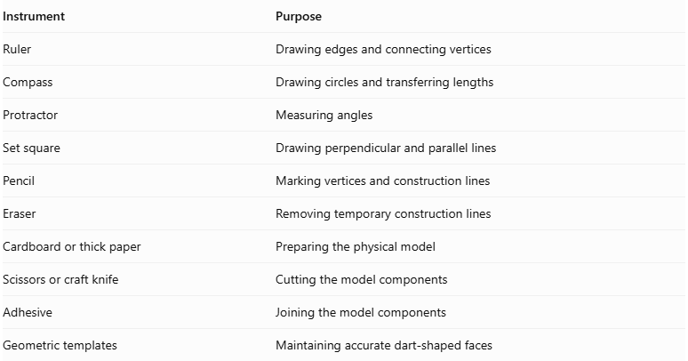
Instrument | Purpose
Ruler | Drawing edges and connecting vertices
Compass | Drawing circles and transferring lengths
Protractor | Measuring angles
Set square | Drawing perpendicular and parallel lines
Pencil | Marking vertices and construction lines
Eraser | Removing temporary construction lines
Cardboard or thick paper | Preparing the physical model
Scissors or craft knife | Cutting the model components
Adhesive | Joining the model components
Geometric templates | Maintaining accurate dart-shaped faces

Instrument-Based Construction Procedures

Establishing the Reference Dimensions
# Source: AI Source: Provided by: [Data Path: Persons Table -> ID Column: 1, Name_En Column: Motasem Essam] -> From: [ChatGPT] on [7/25/2026]
- Choose a convenient reference length for the shorter edges.
- Draw a reference line segment using a ruler.
- Use a compass to transfer the required length.
- Calculate the longer edge using the edge-length ratio.
- Maintain consistent proportions throughout the construction.
The ratio between the longer and shorter edges is:
$$\frac{L}{S}=\frac{21+3\sqrt{5}}{22}$$

Constructing the Dart-Shaped Faces
# Source: AI Source: Provided by: [Data Path: Persons Table -> ID Column: 1, Name_En Column: Motasem Essam] -> From: [ChatGPT] on [7/25/2026]
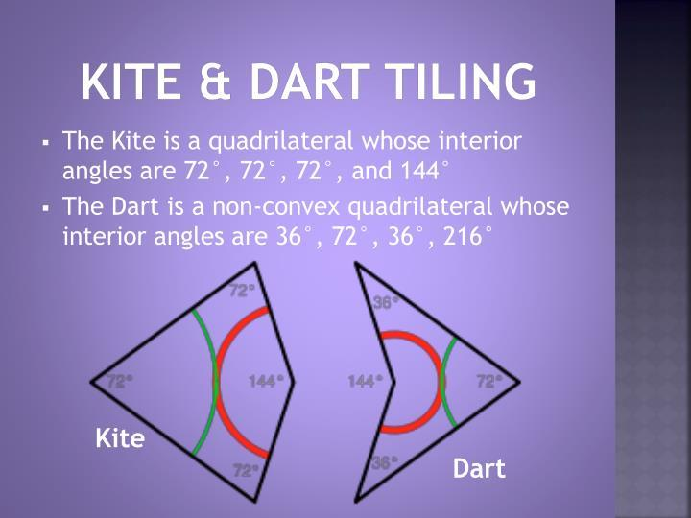
- Draw a reference line for the shorter edge.
- Establish the required positions of the two longer-edge vertices.
- Mark the four vertices of the dart-shaped quadrilateral.
- Connect the vertices in the correct order.
- Verify that two pairs of adjacent edges have equal lengths.
- Check that the face contains a reflex interior angle greater than 180°.
- Preserve the same proportions for every face.
Repeat this construction to prepare 60 congruent dart-shaped faces.

Establishing the Vertex Arrangement
# Source: AI Source: Provided by: [Data Path: Persons Table -> ID Column: 1, Name_En Column: Motasem Essam] -> From: [ChatGPT] on [7/25/2026]
The Great Deltoidal Hexecontahedron contains three types of vertices.
- Identify the 3-valent vertices.
- Identify the 4-valent vertices.
- Identify the 5-valent vertices.
- Arrange the dart-shaped faces according to the dual structure of the Uniform Great Rhombicosidodecahedron.
- Connect the corresponding edges.
- Verify that the complete arrangement preserves icosahedral symmetry.
- Check that the faces intersect correctly.

Constructing the Complete Polyhedron
# Source: AI Source: Provided by: [Data Path: Persons Table -> ID Column: 1, Name_En Column: Motasem Essam] -> From: [ChatGPT] on [7/25/2026]
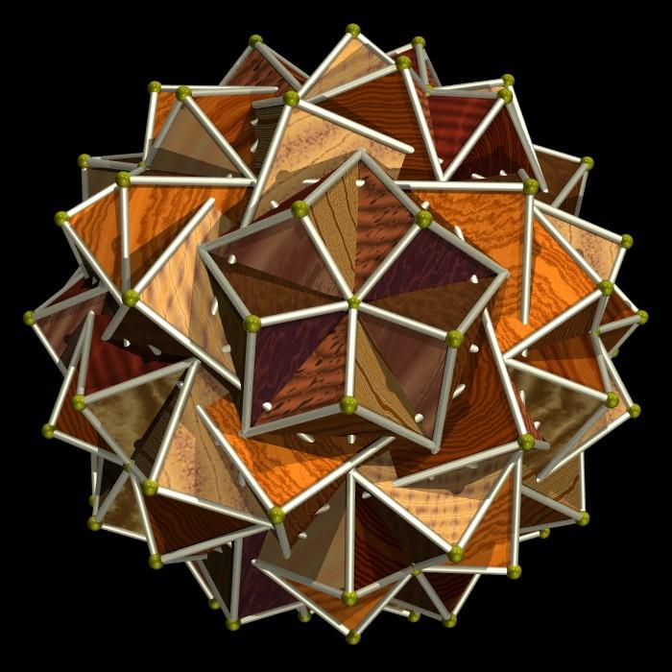
- Use a reference model of the Great Deltoidal Hexecontahedron.
- Identify the positions of the 62 vertices.
- Mark the locations of the 60 dart-shaped faces.
- Construct the faces using the correct edge proportions.
- Arrange the faces according to their intersection pattern.
- Join the corresponding edges.
- Check that the interior portions of the dart-shaped faces are correctly positioned.
- Verify the final structure:
- 60 dart-shaped faces.
- 120 edges.
- 62 vertices.
Construction note: Because this is a self-intersecting star polyhedron, an ordinary flat polygon net may not assemble into the correct solid. A three-dimensional reference model is particularly useful.

Key Points
# Source: AI Source: Provided by: [Data Path: Persons Table -> ID Column: 1, Name_En Column: Motasem Essam] -> From: [ChatGPT] on [7/25/2026]
- The Great Deltoidal Hexecontahedron is a nonconvex star polyhedron.
- It has 60 intersecting dart-shaped faces.
- It has 120 edges and 62 vertices.
- Its edges consist of 60 shorter and 60 longer edges.
- Its vertices have valencies 3, 4, and 5.
- It has full icosahedral symmetry $I_{h}$.
- Its dual is the Uniform Great Rhombicosidodecahedron.
- It should not be confused with the ordinary Deltoidal Hexecontahedron, which is convex and has kite-shaped faces.

Main Classification
# Source: AI Source: Provided by: [Data Path: Persons Table -> ID Column: 1, Name_En Column: Motasem Essam] -> From: [ChatGPT] on [7/25/2026]
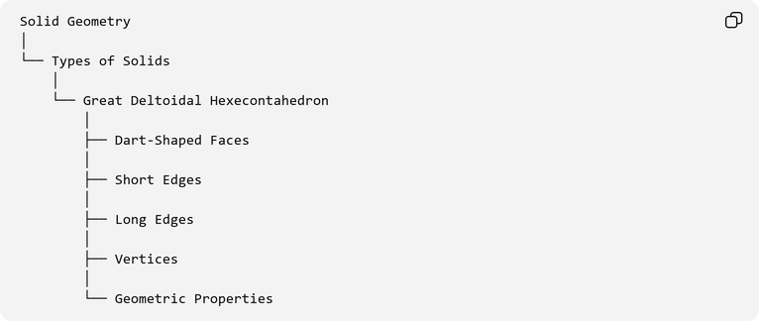
Solid Geometry
│
└── Types of Solids
│
└── Great Deltoidal Hexecontahedron
│
├── Dart-Shaped Faces
│
├── Short Edges
│
├── Long Edges
│
├── Vertices
│
└── Geometric Properties

Conclusion
# Source: AI Source: Provided by: [Data Path: Persons Table -> ID Column: 1, Name_En Column: Motasem Essam] -> From: [ChatGPT] on [7/25/2026]
The Great Deltoidal Hexecontahedron is a nonconvex star polyhedron characterized by its 60 intersecting dart-shaped faces, two distinct edge lengths, and full icosahedral symmetry.
Its dual relationship with the Uniform Great Rhombicosidodecahedron distinguishes it from the ordinary convex Deltoidal Hexecontahedron.
Its unusual nonconvex structure, intersecting faces, and complex geometric arrangement make it an interesting example of advanced polyhedral geometry.

